(Section 3 of 5)

What Students Will Learn to Do:
This chapter will introduce you to the Navy Junior Reserve Officers Training Corps—its background, mission, curriculum, and activities, as well as its benefits to cadets.

Skills and Knowledge to be Gained:
  - Explain the history and background of the NJROTC
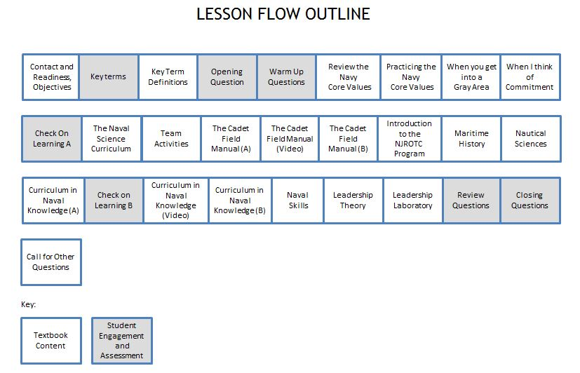
  - Describe the NJROTC’s mission, goals, and policies
Outline of Instruction:
- Preparation
            - Log in to TPC.
            - Expand the folders in the Content Window until you see NS1, U1, C1, S3
Highlight the PPT - NS1-U1C1S3 – Core Values and Curriculum
Click on PowerPoint Polling to open PPT and start slide show

            - Ensure that every student has a functional response pad and a textbook.
II. Instructional Flow:
Flow Item | Textbook Content / Student Engagement and Assessment | Slides
Establish contact and readiness; provide lesson overview and objectives review | Motivate students by relating real or imaginary events to help them see what the lesson will involve. Explain how this lesson ties in with other lessons.  In this lesson, students will learn about the NJROTC program. In addition they will:  1. Be able to state the program’s mission, goals, and policies.  2. Learn that the Navy Core Values- honor, courage, and commitment- are important parts of the NJROTC program, what they mean and how they are exemplified.  3. Learn what the Naval Science curriculum is all about  4. Learn the various activities in which NJROTC units participate.  5. Learn the benefits of belonging to the NJROTC | 1-3
Key term questions Slide index | Index Slide allows you to jump to any key term polling question. Clicking on the house icon at the bottom of any of the key term slides will bring you back to this index slide. | 4
Team Assignment (Hidden) | This is a hidden slide for gaming –It Is NOT required for the lesson | 5
Key terms - Questions | Ask students to respond to the questions covering each key term. | 6-11
Key terms - Definitions | Reinforce the correct definition for each key term. | 12-13
Opening Question-(Randomly Selected Student – “RSS”) | This Opening Question is “List 2-3 things that you are “committed” to. What does it mean that you are committed to these things?” Since this is a discussion question, it can be engaged using the “Randomly Selected Student” icon on PPT slide to select a clicker number randomly That student will orally answer the question (not with his/her clicker). You might allow the students to discuss the question for 30-60 seconds with a partner before engaging the RSS question. The MobiView tablet can be used to write the students’ responses to the question on the slide, focusing on core values and curriculum. | 14
Warm-Up Questions (Lesson questions 1-2) | Warm-up questions are typically used to gauge students’ level of interest, to generate interest in learning about upcoming topics, or to gauge prior opinions, knowledge or confidence in their knowledge, and/or uncover misconceptions that might be present. There may or may not be correct answers to these questions.  Ask students to respond to each Warm-up question, with follow-up discussion based on responses as appropriate. | 15-16
Review the Navy Core Values | Review and explain that If you value your sense of honor, you won’t want to haze or harass anyone. If you have the courage to resist peer pressure, you will be able to avoid misbehavior and even talk others out of it. If you are committed to respect for other people, these behaviors will simply lose their appeal. | 17
Practicing the Navy Core Values | Explain that mastering the Core Values is not a matter of instinct. It is something that you must learn through conscious effort. After time, you will act instinctively on these values. The acronym LATAR is one tool that can help you master the Core Values:  • Learn  • Adopt  • Think  • Act  • Reevaluate.  Learn: Know the Core Values and how they contribute to the Navy’s readiness.  Adopt: Adopt the values as your own and live them 24/7—at home, at school, everywhere.  Think: Recognize when Core Values are being compromised. Speak up if someone makes inappropriate or wrong comments, for instance. The more you live by the Core Values, the more people will notice it. These values, lived, will give you credibility and influence with others. Both you and those you work with will be more effective.  Act: Do the right thing. Apply the Core Values in your dealings with peers and leaders. Report illegal activities if necessary.  Reevaluate: Think about how well your life matches up with the Core Values. Are you falling short? If so, how can you improve? | 18-20
When you get into a Gray Area | Explain that like a ship that’s not securely anchored, you may sometimes find yourself drifting into a moral or ethical gray area. The Core Values can help you navigate around these. Have the courage to examine whether your behavior is honorable. If not, commit to changing your behavior. If your fellow cadets act in a questionable way, have the courage to tell them. This will make it easier to avoid further confrontation. | 21
When I think of commitment | Admiral James Stockdale’s remarks at the U.S. Naval Academy, 31 July 1997 | 22
Check on Learning Questions A (Lesson Questions 3-4) | Check in on student’s understanding of information covered so far by engaging lesson questions 3 and 4, with follow-up discussion as appropriate. | 23-24
The Naval Science Curriculum | Explain that in addition to your studies into the Navy’s Core Values, your studies in Naval Science will cover eight other major areas over the next four years.  This curriculum emphasizes two different areas each year and is customized by your school to meet your needs and the needs of your classmates. In general, the program is meant to provide a balance of classroom studies, military activities, physical fitness, and orientation trips. | 25-27
Team Activities | Explain that most NJROTC units have teams that compete against other units in military drill, marksmanship, color guard performance, and academics. | 28-29
The Cadet Field Manual | Explain that the Cadet Field Manual is your guide to success as an NJROTC cadet. It will show you how to wear and care for a uniform and will explain uniform rates, ranks, and ribbons. The manual also explains military standards of personal appearance. The manual will tell you what you need to know about military customs and courtesies. This includes saluting and proper behavior while in uniform. | 30
The Cadet Field Manual | Show Video on the Cadet Field Manual. | 31
The Cadet Field Manual | Explain that when you master these standards, you will be able not only to take part in unit activities with pride and confidence but also to assist your fellow cadets in their own mastery and understanding of these important codes of conduct. | 32
Introduction to the NJROTC Program | This course will explain the background, purpose, goals, and objectives of the program. It will also help you build important study and time-management skills. These skills will help you in all aspects of your school and professional life, not just in your NJROTC studies. Furthermore, these traits will provide you with the tools required to succeed as a member of your community and as a citizen of the United States. | 33
Introduction to the NJROTC Program | Explain that part of learning how to be a cadet in the NJROTC program is learning how to act as a responsible citizen. You’ll learn how other forms of government around the world over the past century compare with our own. You’ll study the Declaration of Independence and the U.S. Constitution, the founding documents of our republic, and explore how these documents affect your life, the lives of your classmates, and people across the planet. Explain that instructors will explain the role of the armed forces in a democracy, tell you about how these forces are organized, and describe the role of the Defense Department. | 34-35
Maritime History | Explain that navies have been an important part of life for thousands of years as seafaring peoples have sought to trade with or even conquer their neighbors and to explore more of the world. Your instructors will introduce you to maritime history—the history of ships and navies—with emphasis on the role of the U.S. Navy. | 36
Nautical Sciences | Explain that part of understanding the Navy is learning the sciences that go into the operation of ships and aircraft, including sciences that apply to navigation, keeping the ships afloat, and keeping the planes and helicopters in the sky. Several different fields of study make up the nautical sciences. | 37
Curriculum in Naval Knowledge | Explain that you will learn about the concept of sea power as presented by Alfred Thayer Mahan (1840–1914), an influential naval historian who believed that sea power was the key to success in international politics. In his view, the ability of a coastal nation, like the United States, to use the oceans for trade, commerce, science, industry, and national defense would largely determine that nation’s role in the world. | 38-39
Curriculum in Naval Knowledge | Explain that your studies in Naval Knowledge will consider the history of United States strategy from our country’s beginnings to the modern era and how the three classic schools of strategy—sea power, air power, and land power—affect a modern-day engagement. Explain that instructors will explain the national security planning process. You’ll learn about how our government looks at current threats to national security and takes steps to counter them with some of the most advanced surveillance methods on the planet. Coupled with the national security unit, you’ll learn more about the responsibilities of the Merchant Marine and the Coast Guard in the maritime defense of the United States. Your instructors will explain the role of naval operations, communications, intelligence, logistics, and research and development. | 40
Check on Learning Questions B (Lesson Questions 5-6) | Check in on student’s understanding of information covered so far by engaging lesson questions 5 and 6, with follow-up discussion as appropriate. | 41-42
Curriculum in Naval Knowledge | Show Video on curriculum in naval knowledge | 43
Curriculum in Naval Knowledge | Explain that to wrap up your unit on Naval Knowledge, your instructors will explain the differences between military and civilian law and how the Uniform Code of Military Justice, or UCMJ, is rooted in the Constitution. From this you’ll be better able to learn about the sources and principles of international law, and why international law is important to those who go to sea. | 44
Naval Skills | Explain that this is where you will learn about the ins and outs of life aboard ship. You’ll study shipboard organization and the roles of the commanding officer, the executive officer, and other members of the command structure. You’ll also learn about standing watch and such basics of shipboard life as meals and sleeping quarters. | 45-47
Naval Skills | Explain that Naval skills include a wide variety of skill sets unique to the naval environment that fall under the definition of seamanship. This term covers handling lines, preparing to get a ship underway, preparing to anchor, handling small boats, and many other skills specialized to life on a ship. Ship driving, for instance, involves knowing the sea “rules of the road,” which act in much the same way as traffic laws on a highway and are required knowledge for anyone in command of a ship. Your Naval Skills classes will provide you with both International and Island rules, which cover proper signaling (with lights and other means) as well as guidelines for avoiding other vessels | 48-50
Naval Skills | Explain that understanding the 24-hour clock used by all the armed forces is covered by Naval Skills, as is learning about Greenwich Mean Time (GMT). All the Navy’s schedules, operational plans, and navigational aids run on GMT. This means you’ll be better able to relate navigation and time, and have the opportunity to get practical experience in navigation and maneuvering. | 51
Leadership Theory | Explain that in this course instructors will present basic principles of leadership, stressing the importance of leading by example and the role of ethics and morals in leadership. Classes will draw heavily on case studies of actual situations to help students understand the role of the leader in making decisions. | 52
Leadership Laboratory | Explain that this is where senior cadets have the opportunity to serve in positions of authority. They are expected to plan, influence, and direct unit members’ efforts in accomplishing a mission. Many cadets consider these experiences the most exciting part of their NJROTC careers. They will allow you to evaluate and practice the leadership skills developed in class. | 53
Review Question - (Randomly Selected Student – “RSS”) | The Review Question is “What does the acronym LATAR stand for?” Question is designed to provide an opportunity for some reflection and assimilation of the content covered, and is to be engaged with the Randomly Selected Student Icon as the Opening Question above. MobiView can be used here to write the students’ best responses for visual reinforcement, and to foster discussion. | 54
Closing Questions (Lesson Questions 7 - 8) | Have students respond to questions 7 and 8 covering the final segment of the lesson, with follow-up reinforcement and discussion as appropriate. | 55-56
Call for Other Questions | Provide the opportunity for students to ask final questions regarding the content covered. | 57

III. Supplemental Activities -
A. In class Activity:
Supplies required: Handout
When: At the end of class
- Complete Handout: Have the cadets complete the word search with the key words from the lesson.

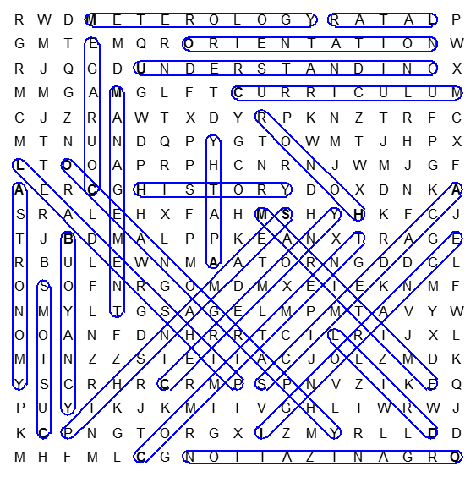
Solution:

B. Homework Activity: Have the cadets look at the 9 sections of NS1-4 Curriculum and fill out the handout “3 Curriculum Areas that Interest You”. Using complete sentences, correct grammar and spelling, have them give details why that particular section of curriculum has interest for them.

IV. Evaluation - see TPC Content Window (U1C1-Assessments folder) for chapter test questions.

Activity 1: In-Class Activity- Core Values and Curriculum
Name: _______________________________ Date: ___________ Class: ___________
Directions: Find the words in the grid. Words can go horizontally, vertically and diagonally in all eight directions.
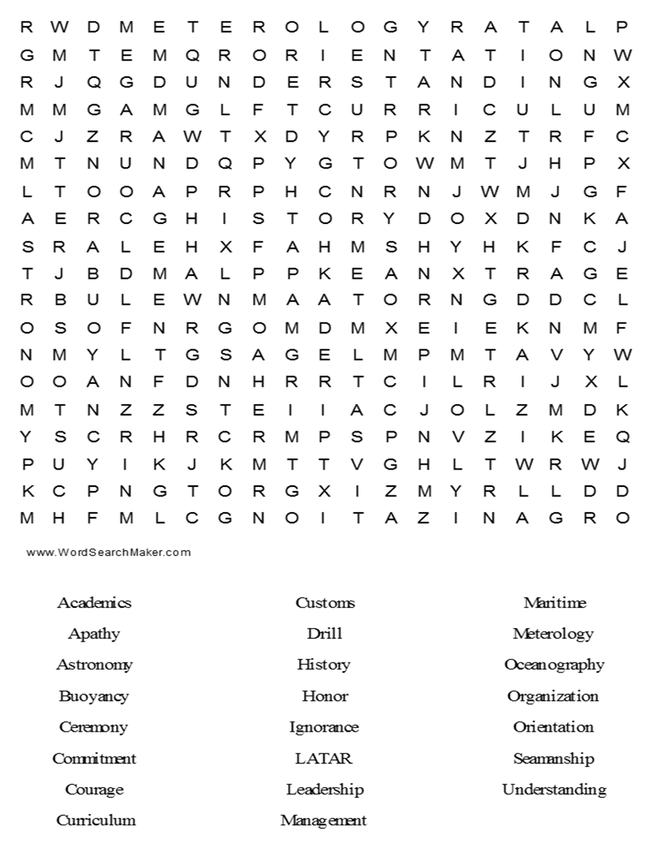
Activity 1: Take Home Activity - Core Values and Curriculum
Name: _______________________________ Date: ___________ Class: ___________

Choose 3 curriculum areas that interest you? Describe your field of interest within the curriculum area and what interests you about the curriculum. (Job opportunities, mission, training, platforms involved (ship, air, land, intelligence) Use complete sentences, correct grammar and spelling.
- _______________________________________________________________________________________________________________________________________________________________________________________________________________________________________________________________________________________________________________________________________________________________________________________

- _______________________________________________________________________________________________________________________________________________________________________________________________________________________________________________________________________________________________________________________________________________________________________________________

- _______________________________________________________________________________________________________________________________________________________________________________________________________________________________________________________________________________________________________________________________________________________________________________________

